|  |
| --- |
| User Manual  Order to cash process(Configuration) |
| REFERENCE: GW/ERP/USER MANUAL |
|  |
| **Genweb2 Ltd.** |
|  |



|  |
| --- |
|  |

# Document Information

|  |  |
| --- | --- |
| Document Name | User manual (Configuration)Order to cash process |
| Document Author | Rashedul Alam |
| Document Version | 1.0 |
| Release Date | 11th April, 2018 |

|  |  |
| --- | --- |
| Review by | Md. Matiar Rahman |
| Review Date | 11th April, 2018 |
| Approved By |  |
| Approval Date |  |

# Document History

|  |  |  |  |  |  |
| --- | --- | --- | --- | --- | --- |
| A=Added, M=Modified, D=Delete | | | | | |
| **Version No** | **Date** | **Section No** | **A/M/D** | **Description of Change** | **Author** |
| 1.0 | 11-April-2018 |  | A | Initial | Rashedul Alam |
|  |  |  |  |  |  |

Contents

A. Document Information 2

B. Document History 2

1. Introduction 4

1.1 Purpose of User manual 4

2. Configuration by HR Manager 4

2.1 Creation of product category by HR Manager 4

2.2 Create Attributes by HR Manager 5

2.3 Create Attribute values configure by HR Manager 6

2.4 Create Unit of Measure (UoM) categories by HR Manager 7

2.5 Create Unit of Measure(UoM) by HR Manager 9

2.6 Create contract tags by HR manager 10

2.7 Create contact title by HR Manager 11

2.8 Create Currencies by HR Manager 12

# 

# 1. **Introduction**

The purpose of this User Manual is to clearly identify the customer requirements and provide a detailed document. The customer will read this document and get a clear view of the sales module. It will also help the review team to validate whether the customer requirements have been fulfilled or not.

## Purpose of User manual

This document is the User Manual of the Order to cash process. It is intended to provide all the necessary information to use this software to develop application software running on the workstation.

# 2. Configuration by HR Manager

Some configuration require for Sales module, Admin user can configure this.

## 2.1 Creation of product category by HR Manager

Product category requires for Product creation, several types of product category are; All, Saleable etc.

We can create Product category using the menu **sales ‣ Configuration ‣ Product category** and click **Create.**

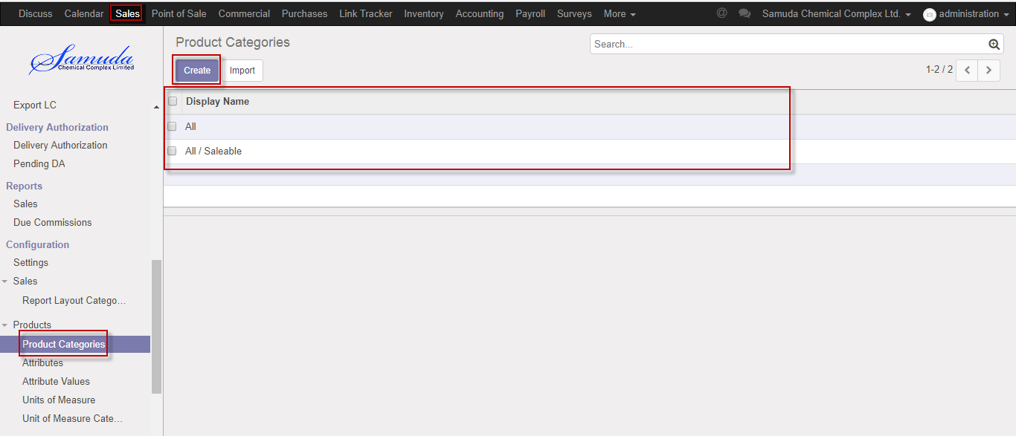

Figure: Product category List view

We need to set the following:-

**Category name**: A Category type name.

**Parent category:** Select parent category.

After entering all information click **Save**.

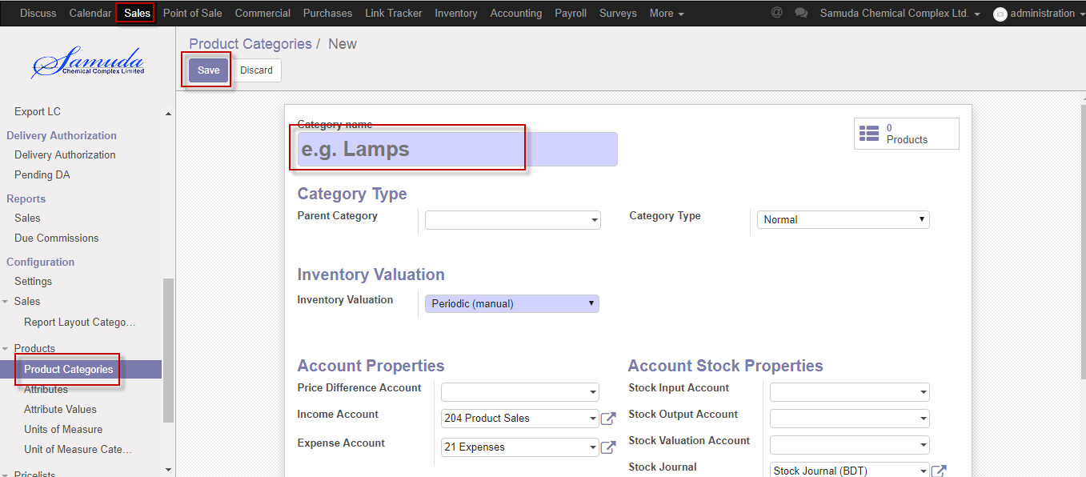

Figure: Create a product category

## 2.2 Create Attributes by HR Manager

Attributes can create by Admin user, Attribute is needed for Attribute value set. It is needed for product value creation.

We can create attribute using the menu **Sales ‣ Configuration ‣ Attribute** and click **Create.**

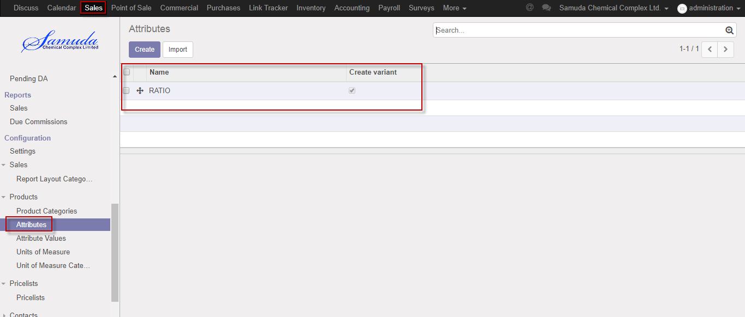

Figure: Attributes List view

We need to set the following:-

**Name:** Enter attribute name.

**Check:** Select checkbox.

After entering all information click **Save**.

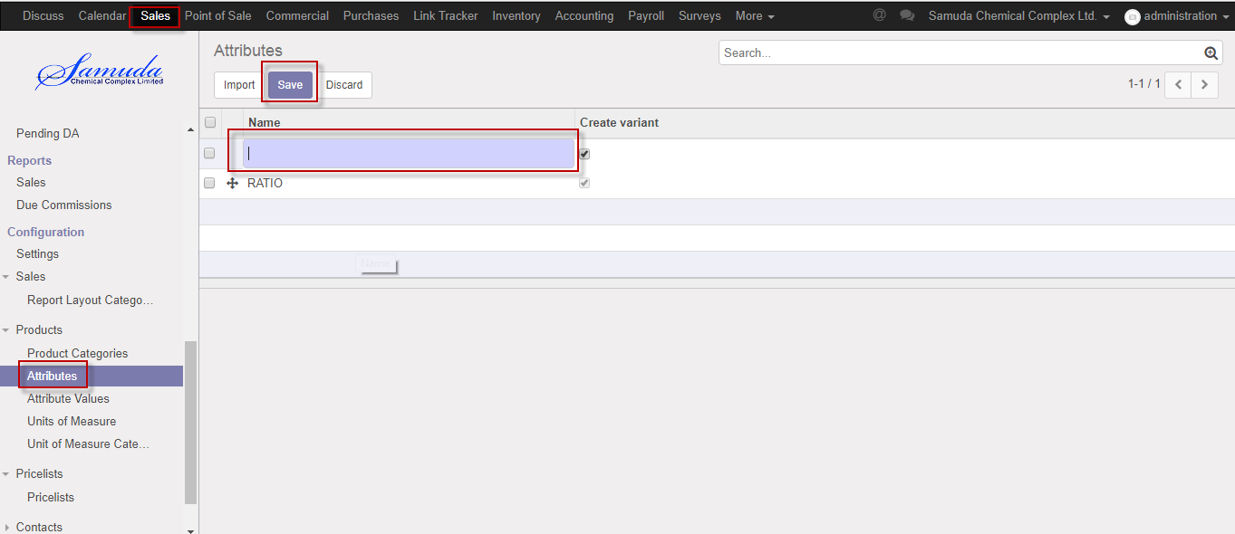

Figure: Create an attributes

## 2.3 Create Attribute values configure by HR Manager

Attribute values can be set by Admin user, attribute values will be needed when we define products different variations.

**Sales ‣ Configuration ‣ Attribute values** and click **Create.**

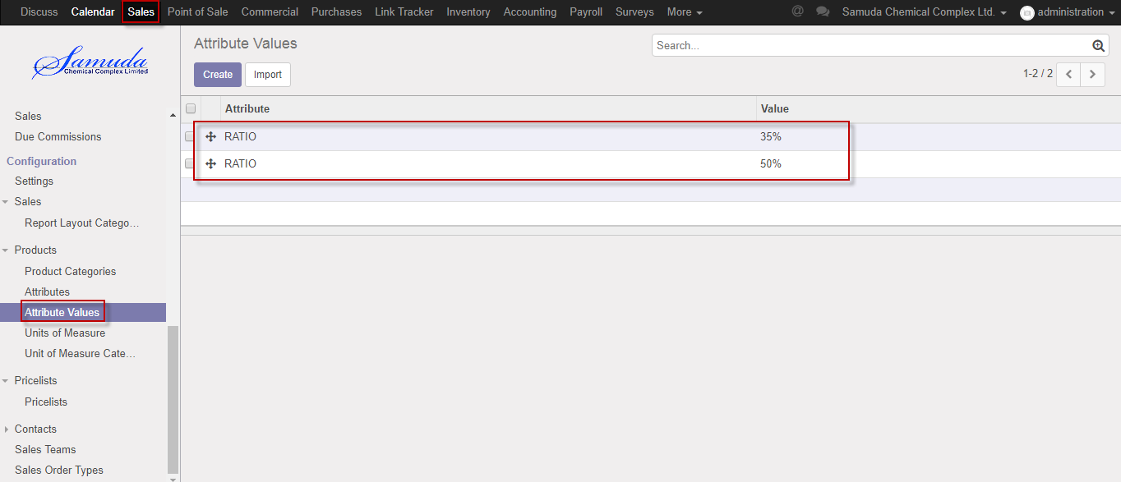

Figure: Attribute values List view

We need to set the following:-

**Attribute**: Select attribute.

**Value:** Enter a value.

After entering all information click **Save**.

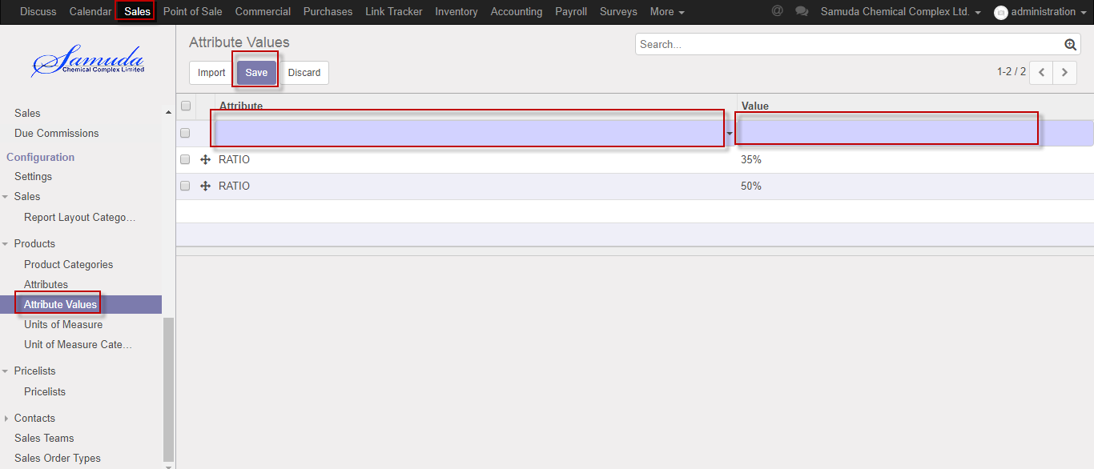

Figure: Create an Attribute values

## 2.4 Create Unit of Measure (UoM) categories by HR Manager

Unit of Measure categories require for Unit of measure entry & it will set by admin user.

We can create Unit of Measure (UoM) categories using the menu **sales ‣ Configuration ‣ Unit of measure categories** and click **Create.**

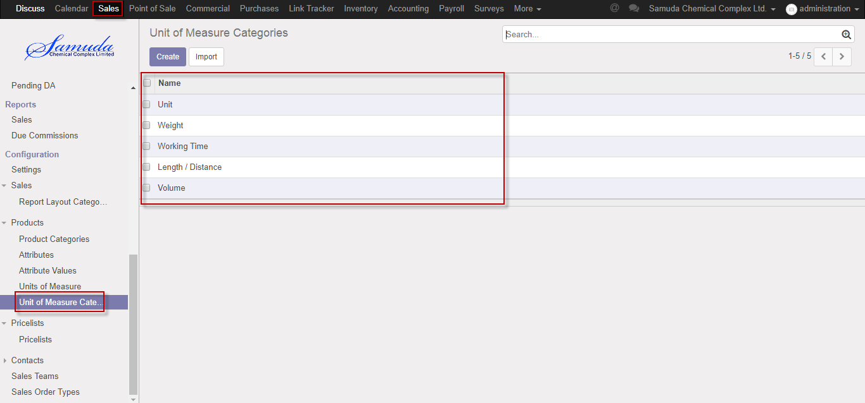

Figure: Unit of measure categories list view

We need to set the following:-

**Name**: Enter a name

After entering all information click **Save**.

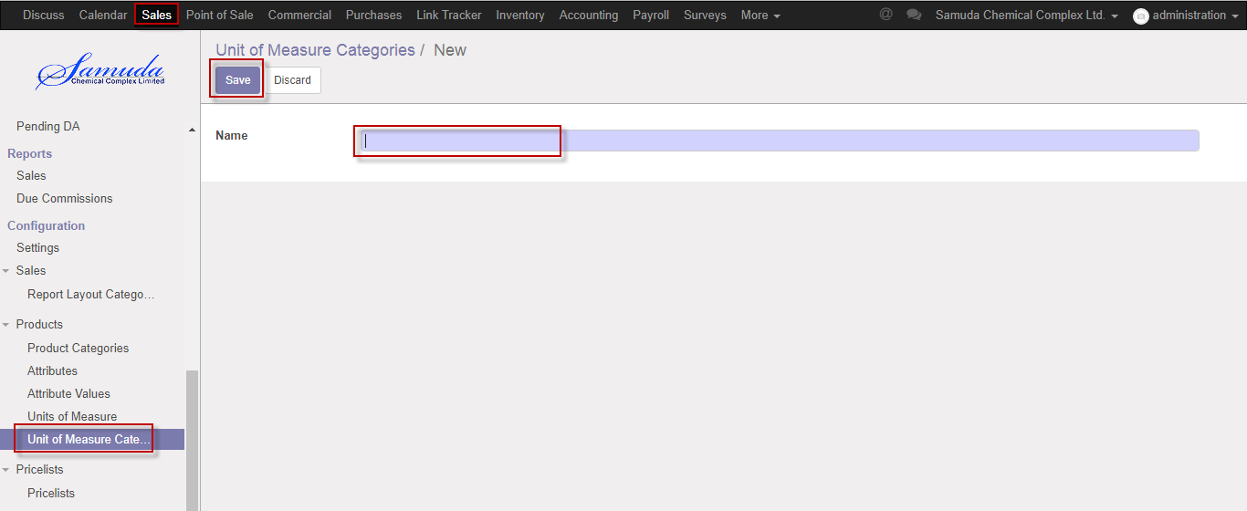

Figure: Create Unit of Measure (UoM) categories.

## 2.5 Create Unit of Measure (UoM) by HR Manager

Unit of measure require for Sales order entry & it will set by admin user.

We can create Unit of measure using the menu **Sales ‣ Configuration ‣ Unit of measure** and click **Create.**

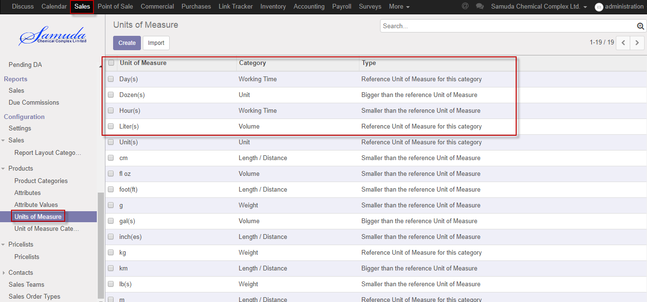

Figure: Unit of measure List view

We need to set the following:-

**Unit of measure**: Enter Unit of measure.

**Category:** Select category.

**Type:** Select a type.

**Rounding precision:** Enter rounder precision time

**Active:** Check active

After entering all information click **Save**.

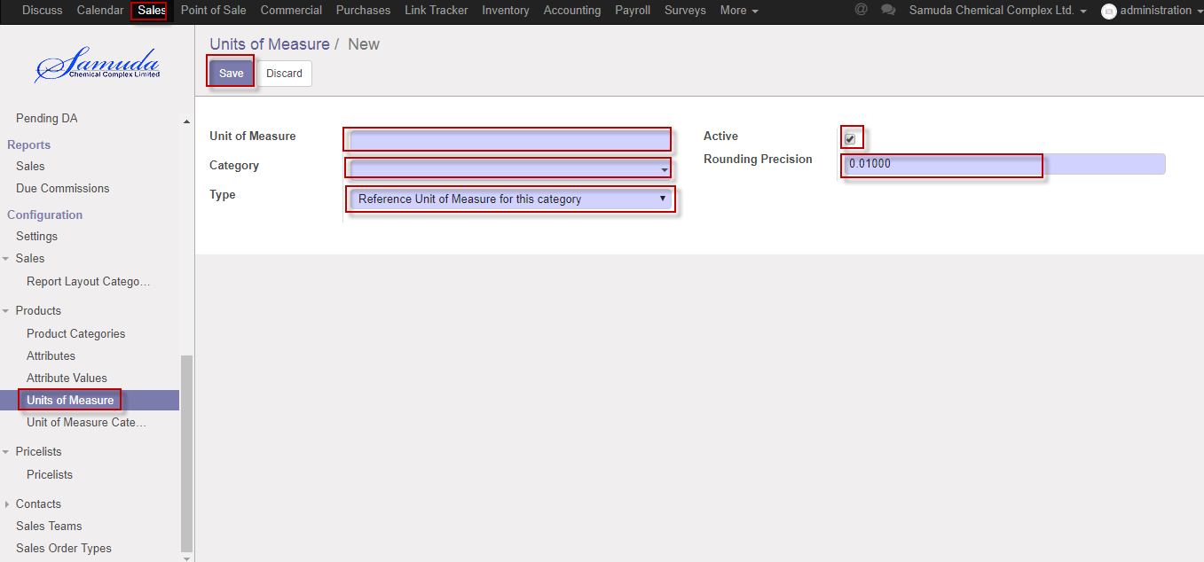

Figure: Create a Unit of measure

## 2.6 Create contract tags by HR manager

Contract tag is need for contract creation .HR manager will set it.

We can create Contract tags using the menu **Sales ‣ Contacts>>Contact tags** and click **Create.**

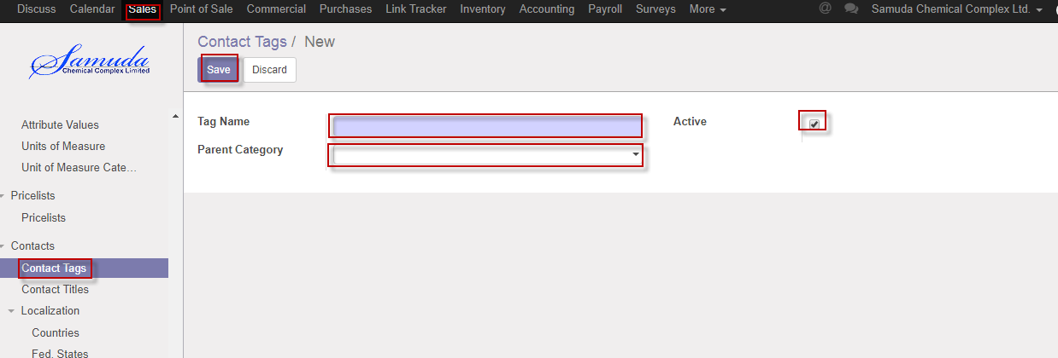

Figure: Create a Contract tags

We need to set the following:-

**Tag name**: Select tag name.

**Parent category:** Select parent category.

**Active:** Check active.

After entering all information click **Save**.

## 2.7 Create contact title by HR Manager

Contract title is need for contract creation .HR Manager will be set it. It will be then used from customers menu.

We can create Contact title using the menu **Sales ‣ Contact>>Contact title** and click **Create.**

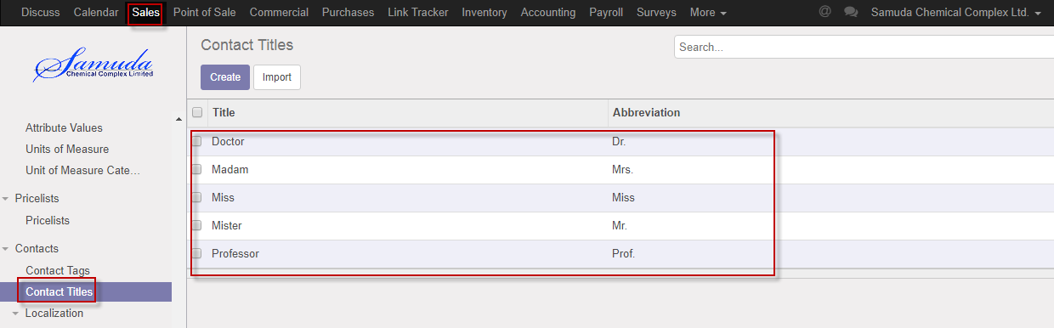

Figure: Contact title List view

We need to set the following:-

**Title**: Enter title.

**Abbreviation:** Enter abbreviation.

After entering all information click **Save**.

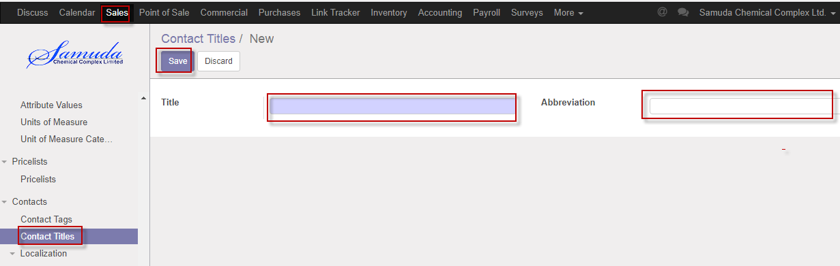

Figure: Create a contact title

## 

## 2.8 Create Currencies by HR Manager

HR manager will set currencies.

We can create currencies using the menu **Sales ‣ Localization>>currencies** and click **Create.**

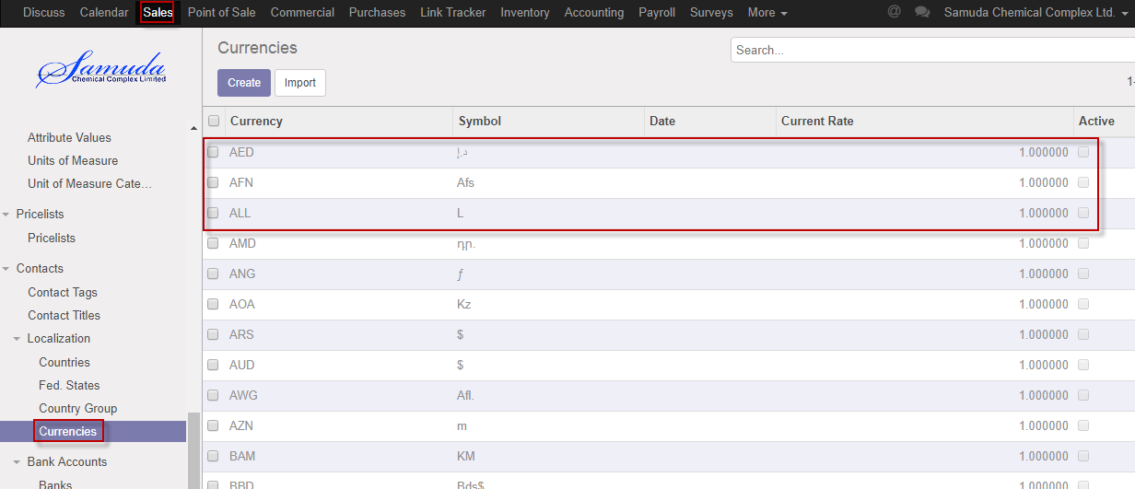

Figure: Currencies List view

We need to set the following:-

**Currency**: Enter currency.

**Rounding factor:** Enter rounding factor.

**Symbol:** Enter symbol.

After entering all information click **Save**.

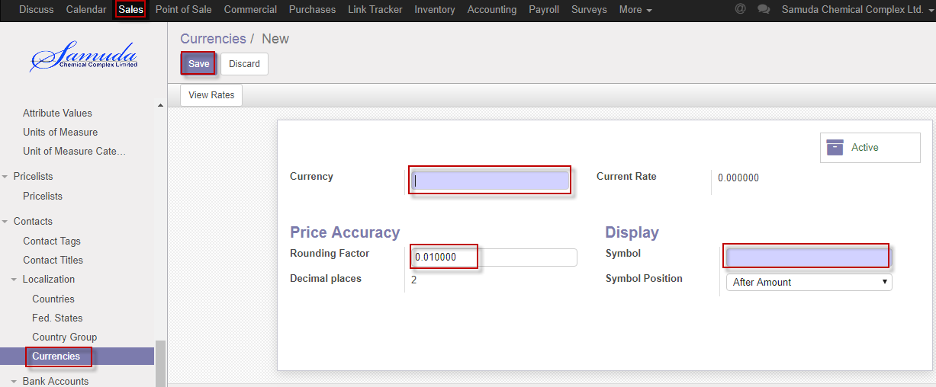

Figure: Create currencies